Vnet Peering and Route Table

🌐 What Is VNet Peering?
Virtual Network (VNet) Peering is a way to connect two Azure VNets so that resources in each can communicate with each other privately over the Azure backbone network—without using public IPs, VPNs, or gateways.
- It’s low-latency, high-bandwidth, and secure
- VNets can be in the same region or different regions (called Global VNet Peering)
🚪 What Is Gateway Transit?
Gateway Transit allows one VNet to use the VPN Gateway of another peered VNet. This is especially useful in a hub-and-spoke architecture.
🔧 How It Works:
- The hub VNet has a VPN Gateway.
- Spoke VNets are peered to the hub and enabled for gateway transit.
- This lets spokes access on-premises networks or other VNets via the hub’s gateway.
🆕 Recent Changes:
- The gateway transit option is now hidden unless:
  - The peered VNet has a VPN Gateway deployed.
  - You’re configuring peering from the hub VNet side.
- You must enable “Use remote gateway” on the spoke VNet and “Allow gateway transit” on the hub VNet2.

🔄 Gateway Transit Behavior
- Gateway Transit allows a VNet (typically a spoke) to use the VPN or ExpressRoute gateway of another VNet (typically the hub).
- This is a key feature in hub-and-spoke architectures, helping reduce cost and complexity by centralizing gateway deployment.
🆕 Azure Portal Change (2025)
You're right—Azure split the old “Gateway Transit” checkbox into two distinct options to make roles clearer:
Option | Location | Purpose
Allow gateway transit | On the Hub VNet | Grants permission for other VNets to use its gateway
Use remote gateway | On the Spoke VNet | Requests to use the gateway from the peered hub
This change improves clarity and aligns with the principle of explicit configuration on both sides of the peering.
🔧 Setup Summary
To enable Gateway Transit:
- On the Hub VNet peering: ✅ Check Allow gateway transit
- On the Spoke VNet peering: ✅ Check Use remote gateway
Both settings must be enabled for the transit to work.
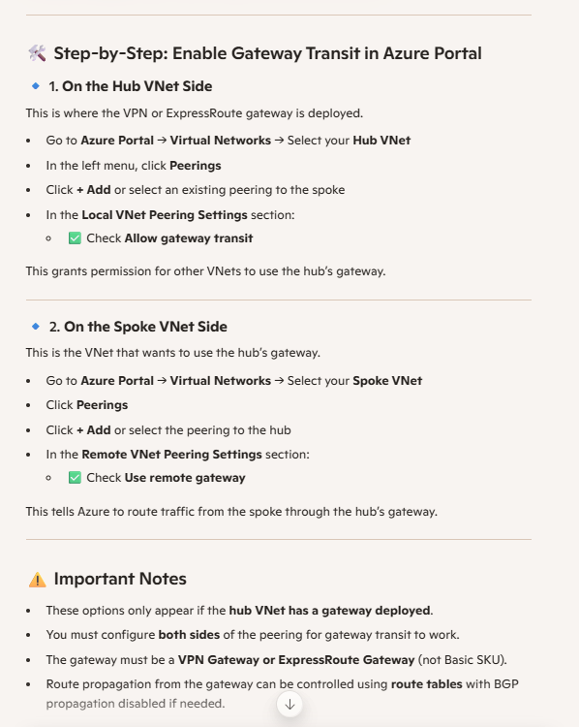
Route Table :
Azure, route tables alone won't enable communication between two separate VNets unless there's a connection mechanism like VNet peering or a VPN gateway.
🧭 What Is an Azure Route Table?
An Azure Route Table is a collection of routing rules (called routes) that define how network traffic should be directed from one subnet to another, or to external destinations.
Each route includes:
- Address prefix: The destination IP range (e.g., 10.0.0.0/16)
- Next hop type: Where to send the traffic (e.g., Virtual Appliance, Internet, VNet Gateway)

🔄 Types of Routes
Route Type | Description
System Routes | Automatically created by Azure. Includes intra-VNet, internet, and virtual network gateway routes.
User Defined Routes (UDRs) | Custom routes created by you to override default behavior. Useful for NVAs, forced tunneling, or isolating traffic.

🚦 Next Hop Types
Next Hop | Purpose
Virtual Network | Default route for traffic within the same VNet
Internet | Sends traffic to the public internet
Virtual Network Gateway | Routes traffic to on-premises via VPN or ExpressRoute
Virtual Appliance | Directs traffic to a firewall, proxy, or NVA
None | Drops the traffic (used for isolation or blackholing)

🛠️ Where You Apply Route Tables
- Subnets: Route tables are attached to subnets, not VNets directly.
- Network Interfaces (NICs): You can view effective routes per NIC to troubleshoot.
- VPN Gateways: Route tables influence traffic between Azure and on-premises.

⚠️ Important Considerations
- Route Precedence: UDRs override system routes.
- BGP Propagation: Can be enabled/disabled when using VPN gateways.
- Effective Routes: Use the NIC’s “Effective Routes” view to debug routing.
- No Overlapping Prefixes: Avoid conflicts between UDRs and system routes.

🚧 Why Route Tables Alone Aren’t Enough
- Route tables (User Defined Routes or UDRs) control how traffic flows within a VNet or to connected networks.
- But they don’t establish connectivity between VNets. They only influence traffic once connectivity exists.
🔗 What You Need for VNet-to-VNet Communication
To make routing between VNets work, you need one of the following:
- VNet Peering: Establishes a low-latency, high-bandwidth connection between VNets. Once peered, you can use route tables to control traffic flow.
- VPN Gateway: Useful for cross-region or hybrid setups. You can route traffic through gateways using BGP or static routes.
- Azure Route Server: If you're using network virtual appliances (NVAs), Route Server can inject routes dynamically across peered VNets.

🧠 Key Insight
Even if you define a route in a route table pointing to an IP in another VNet, Azure won’t send traffic there unless the VNets are connected.

